
Quantum Core System’s
Website objectives
The primary objective of Quantum Core is to provide a seemingly immersive, informative and trust worthy purchasing experience to our consumers in terms of acquiring the Laptops and accessories they may desire. Although secondary goals like brand building and customer support are vital, the platform's core purpose is to convert visitors into customers by showcasing high-performance hardware and accessories.
This type of website is a digital storefront designed to handle the entire customer journey—from initial "discovery" of a new gaming laptop to the "post-purchase" phase of downloading drivers or buying matching accessories. It also functions as a Technical Resource Centre where users come to research complex specifications before making a large investment.
Website Goals
Enabling Informed Decision Making Through:
- Reducing Uncertainty: Providing benchmarks, compatibility guides (e.g., which docks work with which laptops), and comparison tools to help users choose between models.
- Transparency: Listing business is such as warranty coverage, return policies, and repair timelines to build consumer trust.
Providing An Understandable And Easy User Interface Through:
- Simple & Descriptive Labels: To avoid using in-depth technical terms in the main menu which some visitors may find confusing incorporating terms such as “Accessories” , “ Brand”, “ Price Range” would be idle than saying "Peripheral Ecosystem”.

- Immediate Feedback: When a user clicks a button or applies a filter, the UI should react instantly—such as a button changing colour or a loading bar appearing—so the user knows their action was received.

Professional Categorisation of Laptops And Accessories Through:
- Intuitive Product Filtering: Since tech buyers care about specific specs, place filters for CPU, RAM, and GPU in a prominent sidebar. Use "chips" (removable tags) at the top of the results to show which filters are currently active.
- Categorised Navigation: Grouping products logically e.g having “Gaming” category and a “Work” category each with its own sub-links for laptops and accessories.

Target Audience ( Demographics And Technical Aptitude)
Demographic: Mainly targeting personnel between the ages of 18-35 currently residing within either the two major cities or the 5 towns found within the country whom have an intuitive or even a subtle interest in purchasing quality laptops.
Technical Aptitude: A mid to high technical aptitude will be required as the visitor or consumer is expected to be highly specific into the frame work, chip sets and specs of which laptop they wish to purchase.

Information Design & Taxonomy:
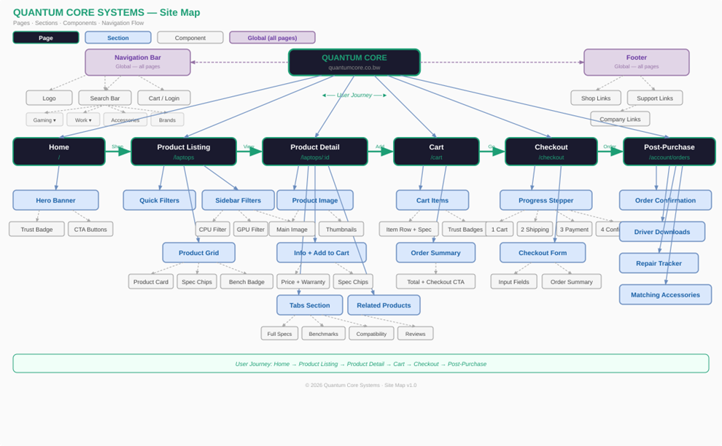

Technical Brief
The Planning And Design Stage
- Lucid chart: Can be used for Wireframing and UI Design. This is where ill decide where the buttons go and how the "Split Hero" section looks before you write a single line of code.
- Canva: Used for Asset Creation. I use these to crop your laptop images, remove backgrounds, and design your brand logo
Frontend Development
- VS Code: Your Integrated Development Environment (IDE). This is the "workshop" where i will be actually typing my HTML, CSS, and JavaScript.
- Next.js & Tailwind CSS: These are your Frameworks. I use them inside VS Code to build the responsive layout, navigation bars, and product cards i planned in Lucid chart.
- Framer Motion: Used for Interactions. I apply this tool to make my product cards "pop" or fade in as the user scrolls down the page.

Backend & Data Management
- Supa base or Fake StoreAPI: Used for Data Storage. This is where the technical specs (RAM, CPU, Price) for your gaming and work laptops are stored so they can be "called" onto the webpage dynamically.
- Snip cart : Used for E-commerce Logic. You integrate this to handle the "Add to Cart" functionality and the checkout math.
Deployment & Hosting
- GitHub: Used for Version Control. You upload your code here to keep a backup and show your professor your "commit history" (how much work you did over time).

